Alabama Unemployment Insurance (UI) benefits are available to workers who are unemployed and who meet the requirements of state UI eligibility laws.

You may file a UI claim in the first week that employment stops or work hours are reduced.

For assistance or more information about filing a UI claim, call 1-866-234-5382 or visit www.continuedclaims.labor.alabama.gov.

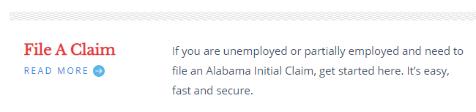

You will need to provide the state UI agency with the following information in order for the state to process your claim:

1. Your full legal name;
2. Your Social Security Number; and
3. Your authorization to work (if you are not a US Citizen or resident).

